**TECHNOCRAZY**

The extraordinary event aimed to discuss innovative technologies, ideas and projects that may find their business solutions in the cross border economy. If you have the passion to think out of the box which can evolve as a new technology then you’ve reached the right place i.e. “TECHNOCRAZY ”.

**RULES**

1. Demonstration time is maximum 10 mins.
2. Make a small team ( 2min. and 3 max. participants).
3. Decision of the judges will be final and will not be subjected to any further discussion.
4. Open for all branches.
5. Spot entries are allowed.
6. Any act against the spirit of the event will lead to disqualification of the team.

(Note: For any queries please contact event coordinators).

**FEE**: Rs.200/- per team

**PRIZE:**

Ist PRIZE-Rs 2100/-

IInd PRIZE-Rs.1100/-

**Round1:** Participants willbe judged on the basis of their perfect ideas and creativity level.

**Round2:** In next and final round ,the participants will be judged on their basis of socio-economic use and implementation.

**Faculty Coordinators: Student coordinators:**

Mrs.Sonali Chadha 8058600010 1.Venugopal Gautam 9461242447

Mr.L.Senthil 8952934577 2.Vaibhav Jain 9024198609

3.Himanshu Jain

4.Himani Jharotiya

5.Himank Kumawat

6.Kanika Khandelwal**7014383630**

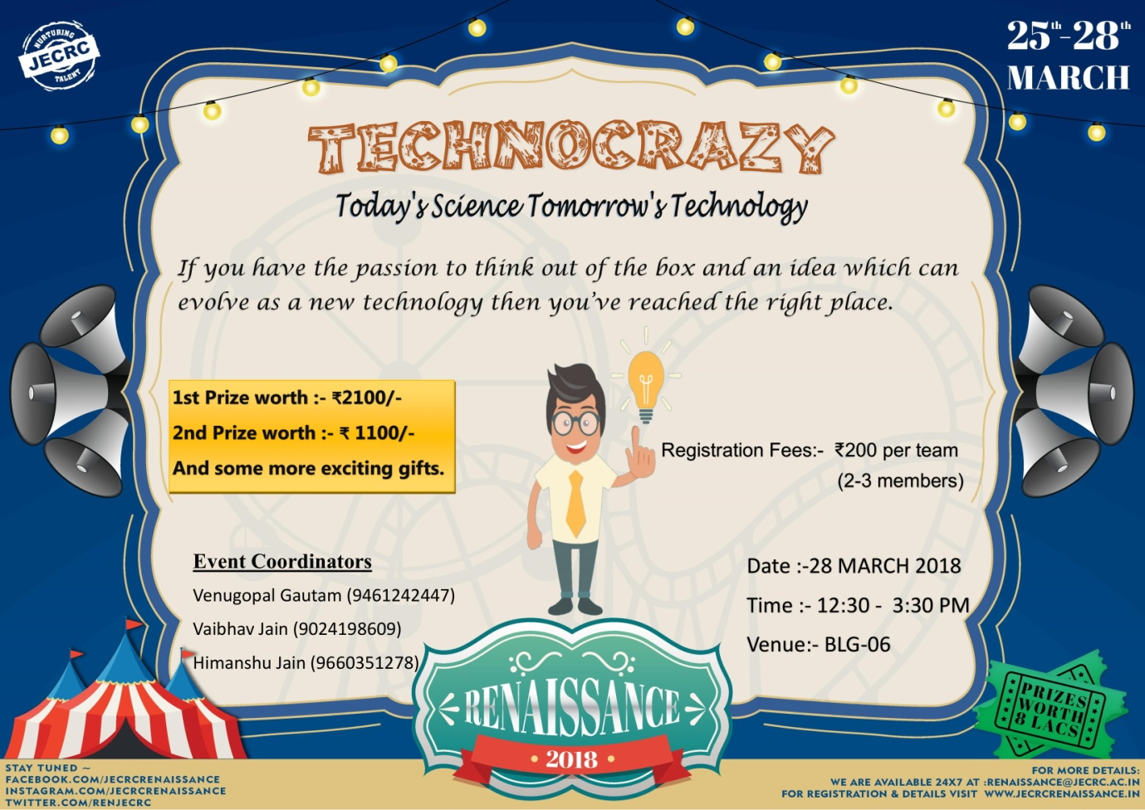

**TECHNO WORD CONTEST**

**Detail of event-**

Event will be organized in 3 rounds

**Round 1**- Team will be asked to identify the given components of electrical and electronics engg.

**Round 2**- A word will be given to per team and they will have to write technical names starting on that word.

**Round 3**- Every team will have to describe an instrument on basis of a given word/name.

Incoming amount

25 Team*Rs150=Rs. 3750 (Team comprises 3 students)

Expense will be :

S.No. Prize Amount

1 1st prize Rs 1100

2 2nd prize Rs 500

3 Poster & Decoration Rs 1250

4 Miscellaneous Rs 900

Total Rs. 3750

**Faculty coordinator :** **Student Coordinator :**

1) Mr.Atul Kulshrestha 9414573167 1)Rohit kumar gupta9694325441

2) Mr. Manish Pal 9928481890 2)Sourabh Sharma 7790834318

3) Mr.Sunil Kumar Sharma 7737509326 3)Deepak sharma

4)Tabish Akhtar 5) Pooja Goswami 7732971944

6) Akshita Gaur 7) Akshay Sharma

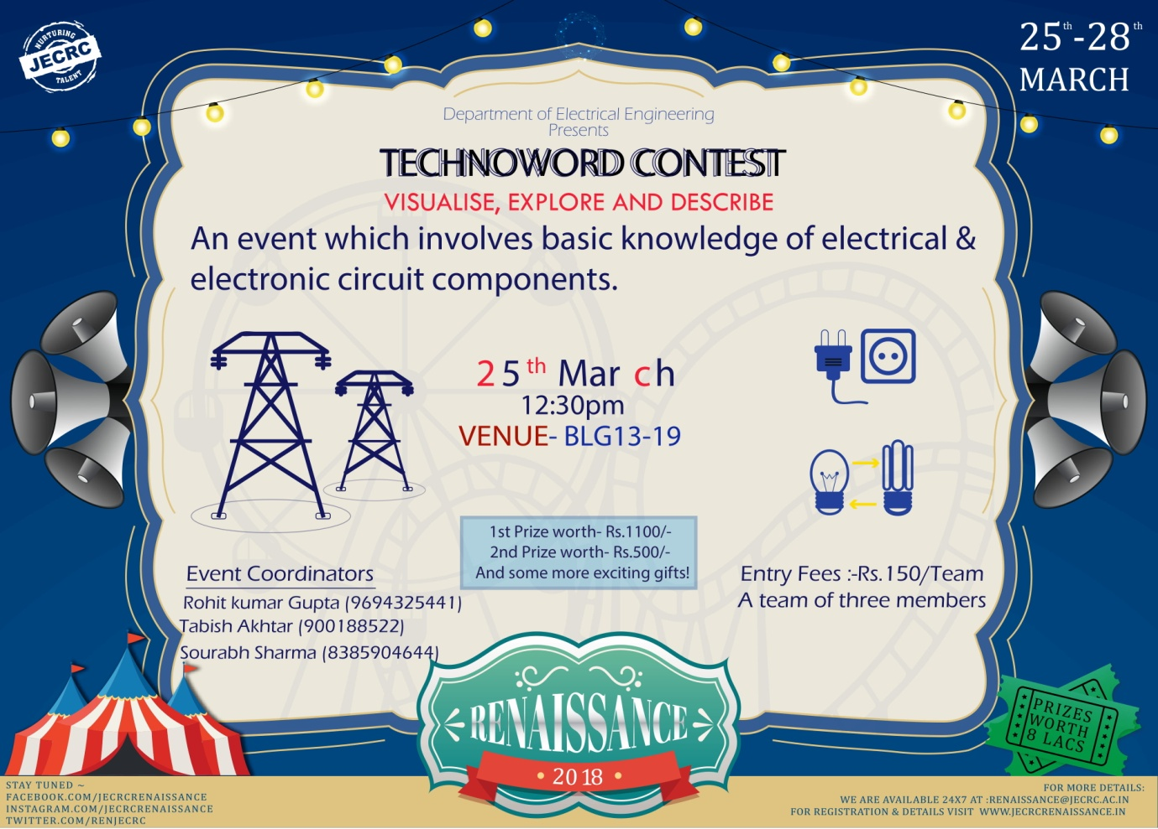

POSTER PRESENTATION

A self-explanatory poster has to be designed. The theme of the poster will be decided by team related to innovation and technology.



**Rules and regulations:**

* Maximum of 2 participants.
* The title of the poster should convey the basic theme of the poster.
* Written matter on the poster will be given least priority.
* Maximum time of 8 minutes is given per team to elaborate the poster.
* Questions will be posed by judges for 2 minutes.
* The winners are decided on the basis of above criteria by the judges.

**Registration fees:** Rs. 150 per team

Expected participants team 20  
Prize: expected 1500rs for winner and runner up.  
Budget for the Event is 2000rs only.

**Faculty Coordinator Student Coordinator**

1. Mr. Rahul Kumar Malee 9785845882 1. Lakshay Kumar 8387986886 2. Mrs.Ravita Saraswat 9457488848 2. Pramod Kumar 7062777164

3. Roshan Jain 9610893163

4. Mahipal Singh 8899791956

5. Sangeeta Sharma 8385815051

6. Prakhar Joshi 9630466547

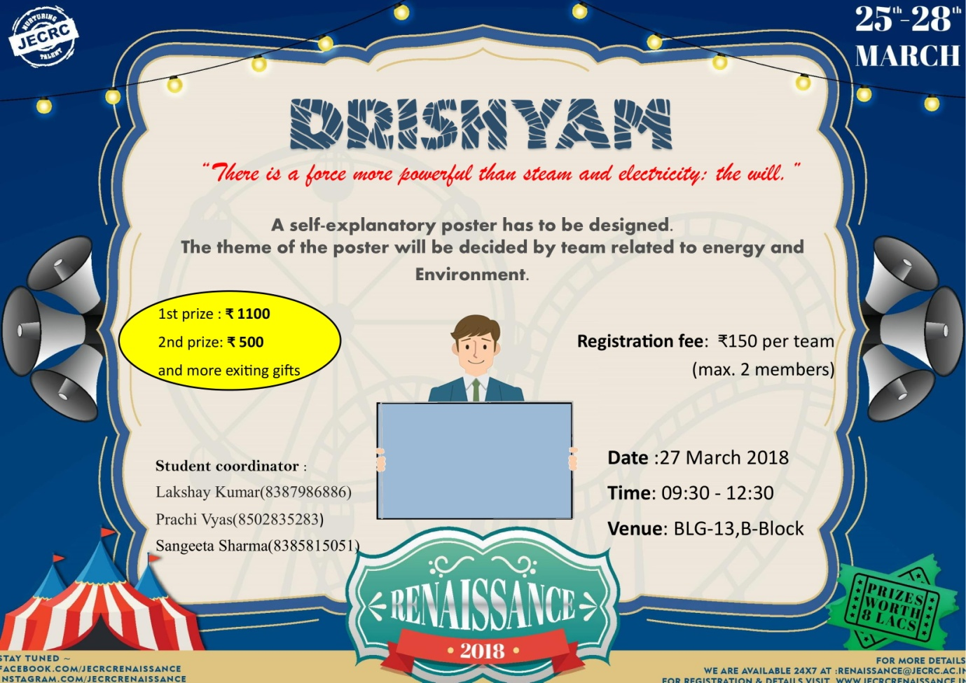

**ELECTRAZONE**

This is an event which involves circuit analysis and basic electrical knowledge and the skill to perform and execute the theoretical laws practically.

**RULES:**

**Round 1**:

1. 30 questions of 3 mark each.
2. (-1) for each incorrect answer.
3. Top 12 teams will qualify for the second round.
4. Time limit 15 minute.

**Round2**

1. Each valid Answer contains 5 points.
2. Each invalid answer has mark deduction of 1.
3. Top 5 teams will be selected for 3 rd round..
4. 5 component list will be provided for each team and for each component 3 mins will provided .hence total round time is 15 minutes.

**Round 3:**

1. Maximum hints allowed to each team are 2.

2. Every hint comes with a point deduction.

3. Points will be given according to the logic used and time taken.

4. If logic used is same then team submitting first will get higher.

5. Team with higher points will be winner.

**FEES: Rs.150 (For one team of two members)**

**1st Prize: Rs.1100**

**2nd Prize: Rs.700**

**Faculty Coordinators: Student Coordinators:**

1. Poonam Gupta 8058600010 1. Anurag Sharma (IIIyr )(99461190225

2. Rahul Kumar Malee97858458822.Nikhil Bindal (IIyr) (9461623306)

3. Devesh Gupta (IIyr)(9667700543)

4.Shaiphali Jain (IIyr) 982282121

5.Somya Paliwal (IIyr)(958710498)

6.Isha Jain (IIyr)(7297867723)

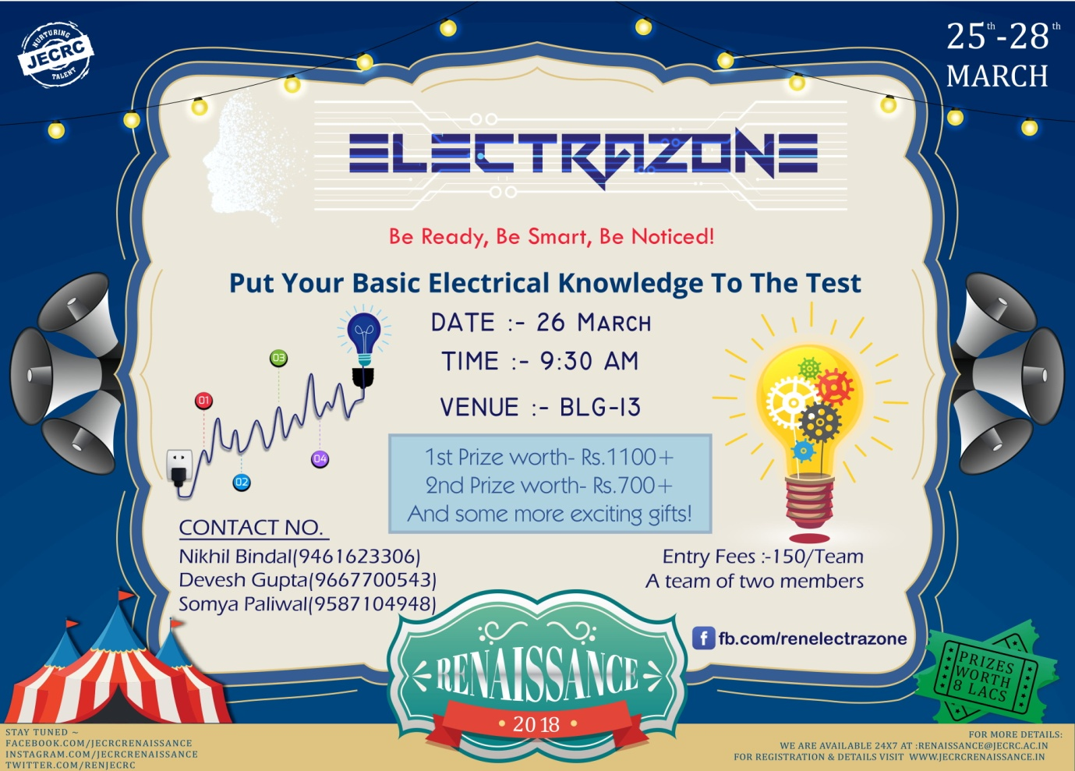

**TECHNICAL CROSS WORD**

It’s amazing how few square boxes can screw your happiness. The best crossword puzzles are in store for you so come on and embrace the challenge. Bring it on!!!!!!



**Event details:-**

* Each team can have max of 2 participants.
* The event is categorized for 3 rounds.
* There is a preliminary round followed by two technical rounds to reach the finals.
* Maximum time of 15 minutes is given every team to solve the cross word.
* Each round has the process of elimination.

**Registration fees:** Rs. 150 per team

Expected participants team 20   
Prize: expected 1500rs for winner and runner up.  
Budget for the Event is 2000rs only.

**Faculty Coordinator Student Coordinator**

1 Mr. Ashok Singh Chundawat 9887708601 1. Padmakshi 9462572461

2. Mrs. Yajusa Sharma 9982421234 2. Neha agrawal 9782274299

3. Mr.Vishnu Datt Sharma 8107478865 3. Nirmal Lakhara 8829888910

4. Mr. Vishal Sharma 9829083223 4. Nikhil Lohar 7296987829

5. Yash Goutam

6. Harshit

7. Anubhav Sharma

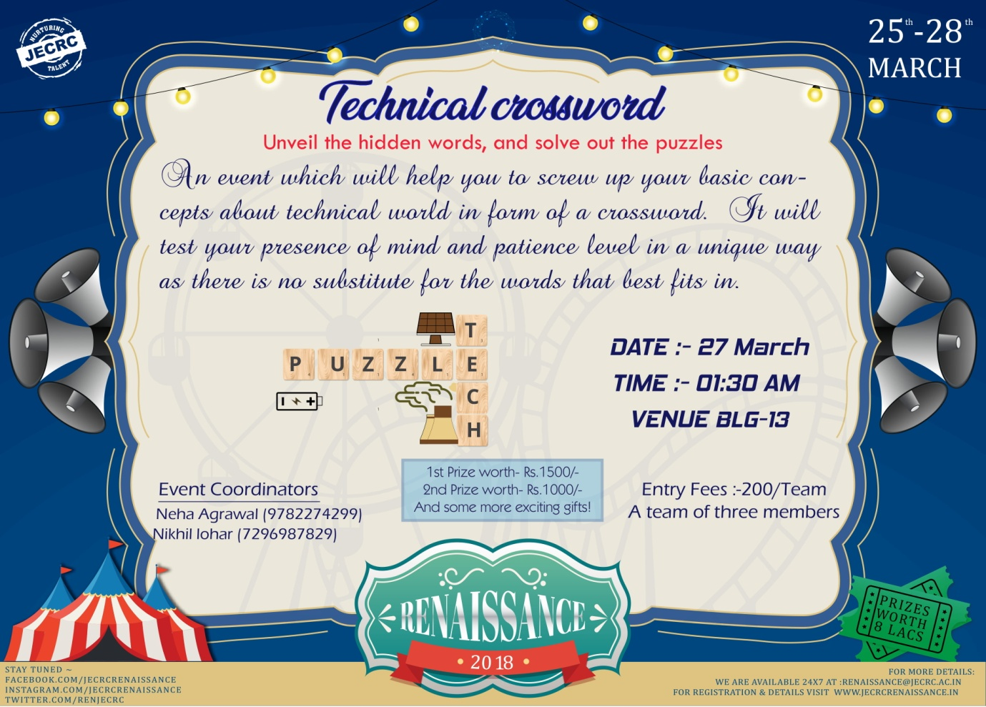

**ELECTRO QUIZZERS**

**Rules for quiz**

1. In a team the maximum of 3 members.
2. Quiz will be based on the basic electrical and electronics syllabus with some interesting questions.
3. There will be 3 rounds.
4. Teams not having cut off marks in each round will be eliminated.
5. In case of any tie there will be sudden death question where team giving correct answer will qualify for next round.
6. 1st round will be visual round where questions will be displayed and students will have to answer them.
7. 2nd round will be based on general and logical technical questions.
8. 3rd and final round will be buzzer round.
9. Team with maximum points after the end of 3th round will be declared winner of the quiz.
10. In case of any conflict the decision of judges would be final.
11. Use of internet will be strictly prohibited. Any team found with this would be disqualified.

**Expected Teams**: 25 (Three members in each team)

**Participation fee**: Rs. 150/- (Each Team)

**Expected Amount Collection**: 25X150 = 3750/- (In Rs.)

**Prize Money:**

1 1st Prize Rs.1100/- +Gift Voucher2 2nd Prize Rs.500/- + Gift Voucher

**Expected Expenditure**: Rs. 1800/- (Detail given below)

Poster: 600/- Petrol: 600/-

Invitation card: 100/- Decoration: 300/-

Miscellaneous: 200/- Total Expenditure: (1600+1800) =3400/-

Date: 26/03/2018

Time: 11:30PM to 2:30 PM

Venue: IBM lab

**Faculty coordinator : Student coordinators:**

Mr. Shailendra Shrivastava 9024699748 1) Bhanu Khandelwal

Mr.Manish pal 9928481890 2) Aman Gupta

3) Aditya Soni**7023852207**

4) Vaibhav Gupta

5) Nikhil sahu 7297832783

6.) Pankaj Kumar

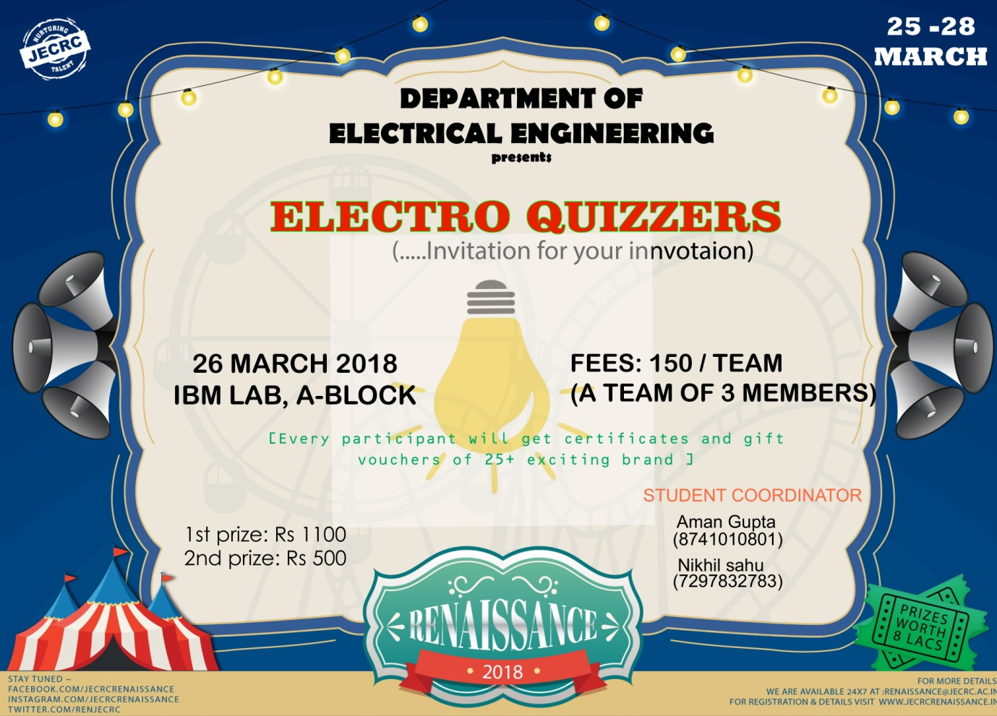

**TECH HUNT**

An event which brings out the technocrat in you, where each team races against time through the daunting physical tasks to be the first in finding the hidden treasure.

RULES:

1. Any student within the age group of 18 - 25 years can participate and each team should consist of not more than three members.
2. Participants from different institutes can form a team.
3. A Maximum of 3 Students per team are allowed to present a team in case of team participants, both the member are required to be present at the time of event.
4. The Decision of the judges will be final and binding.  
   The event will consist of two rounds: The Preliminary round and The Finals. The strength of the team must be 3 members.
5. Use of mobile phones or any other electronic or communication device is prohibited during the event.
6. Participants should note that they must accompany the committee member assigned to them till the event ends.
7. The clues are to be found in a particular order. Manipulation of the order of clues will lead to disqualification.

Round 1(Preliminary round) :  
This is the preliminary round which is a written test. The participants will have to answer a questionnaire based on topics related to electrical and electronics engineering. They will be given 30 minutes to answer the questions and the Top 30 teams will qualify for the next round.  
Round 2(X fire) :  
The Team members selected in first round will participate in this round. 2 teams will stand opposite to each other. There will be a Rapid fire questioning round between these teams. There will be bucket placed for each team and a level of water will be set so as one team makes mistake the other team will put water in the bucket of that team. The team whose bucket will fill upto the level indicator the buzzer will make sound and red light will glow. The team whose bucket will fill first and red light glows will be disqualified from the race of the event.

Round 3(Finals):  
In this round, the teams will be provided with their first clue simultaneously which when deciphered leads them to the next location in the campus where they have to perform a task revealed on spot to obtain the next clue. Following these clues participants have to find circuit parts & assemble the circuit. The team which will submit the circuit in minimum time will be the winner.

If number of teams will be more than we can extend it to one more round by making that round

more difficult.

**Fees:** Rs. 200 (Per Team)

**1st Prize: Rs. 2100**

**2nd Prize: Rs. 1200**

**Faculty Coordinators: Student Coordinators:**

**1.Geetika Mahur (9549318998) Vaibhav Gupta (7734820627)**

**2. Neha Agrawal (8058404226) Jyotsna (7413036969)**

**Himani jharotiya 9587199808**

**Kanka khandelwal7014383630 Anmol bishnoi 9521443901**

**Sourabh Sharma7790834318**

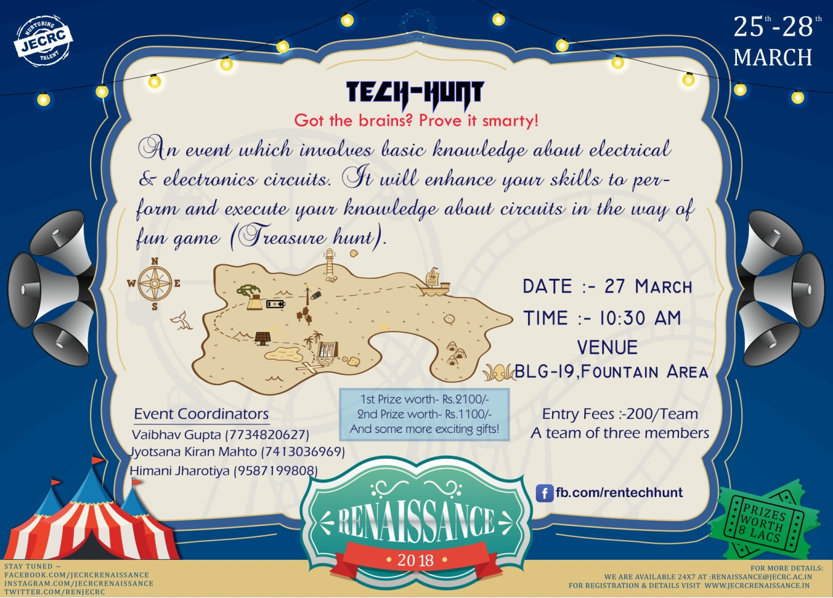

**EMBRIO-Electrical**

Rules and regulations:

* The complete abstracts and hard copies must be submitted under IEEE format only.
* The abstracts of the papers must be sent to [paper.ee@gmail.com](mailto:paper.ee@gmail.com)
* Maximum of 2 participants.
* Maximum time of 8 minutes is given per team to present their papers.
* Questions will be posed by judges for 2 minutes.
* Two hard copies and one soft copy with an abstract containing 200 words are to be submitted at the time of event.
* The winners are decided on the basis of above criteria by the judges.
* No queries regarding results are entertained and the decision of the judges is final.

**Registration fees for your event:** Rs. 150/- per team OR Rs. 100/- per student

Expected Entry: 100 team & maximum team size -2

Topics for presentations: Engineering, science and technology

Total Prizes: 9 (2nd year, 3rd year, 4th year)

Budget: (a) Consolation prizes –Rs.6700/-

(b) Promotional materials and petrol –Rs.1000/-

(c) Mementos- 11(Winner’s and judges)

**The budget for your event:** Rs.7700/-

Date: 27/03/2018

Time: 2:00Pm to 5:00 Pm

Venue: A block Conference Hall

**Faculty Coordinator: Student Coordinator:**

1. Neha Agrawal ,M-8058404226 (1) Isha Jain 7297867723
2. Gopal Tiwari ,M-8890750291 (2) manshi Sharma 8107734791
3. Ram Singh , M-9887712330 (3) Sangeeta Sharma 8385815051

(4) Prakhar Joshi 9630466547

(5) Ayush Agrawal

(6) Ashish Agrawal 9782764781

(7) Akansha Sinha

(8) Saurabh soni 9982675185 (9) Roshan Jain. (10) Sakshi gupta 8441069645

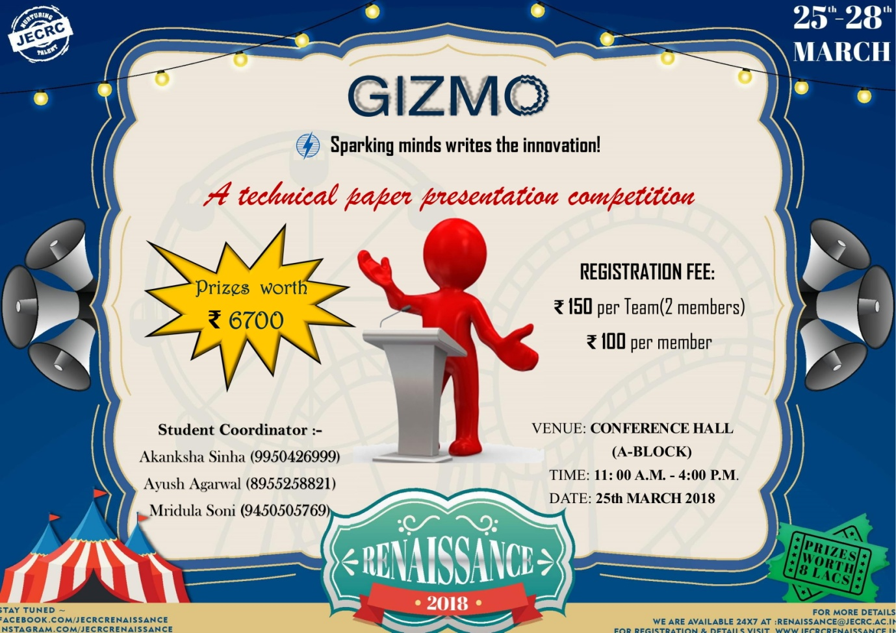

**THOUGHT BAZOOKAS**

**Rules for event:**

1. In a team the maximum of 2 members.
2. contest will be based on the scientific principal, themes and with some interesting questions.
3. There will be 3 rounds.
4. Teams not having cut off marks in each round will be eliminated.
5. In case of any tie there will be sudden death question where team giving correct answer will qualify for next round.
6. 1st round will be visual round where scientific principal or mathematical relation will be displayed and students will have to answer about the scientist who proposed that theory
7. 2nd round will be theme based questions (Buzzer round),in this round themes will be already given to participants and a picture displayed on basis of that theme, participant have to tell what is that and where that is situated.
8. 3rd and final round will be based GIF that will display on screen with assembling the part of an machine final, candidates have to recognize the parts, who will ans. Maximum part’s name that will be winner .
9. In case of any conflict the decision of judges would be final.
10. Use of internet will be strictly prohibited. Any team found with this would be disqualified.

**Expected Teams**: 30 (Two members in each team)

**Participation fee**: Rs. 150/- (Each Team)

**Expected Amount Collection**: 30X150 = 4500/- (In Rs.)

**Prize Money:**

1 1st Prize Rs.1500

2 2nd Prize Rs.500

**Expected Expenditure**: Rs. 1700/- (Detail given below)

Poster: 600/-

Petrol: 500/-

Invitation card: 100/-

Decoration: 300/-

Miscellaneous: 200/-

Total Expenditure: (1600+1700) =3300/-

**Faculty coordinator : Student coordinators:**

1) Mr.Manish Pal 9928481890 1.Aman Agrawal 8955983532

2) Dr. Sandeep Vyas 9413965018 2.Abhishek Agrawal 9529376980

3.Anirudh singh 9057563553

4)Yogesh Sharma 8963858000

5) Inshira shirin 8107262988

6) Ashu Makkar 8302043226

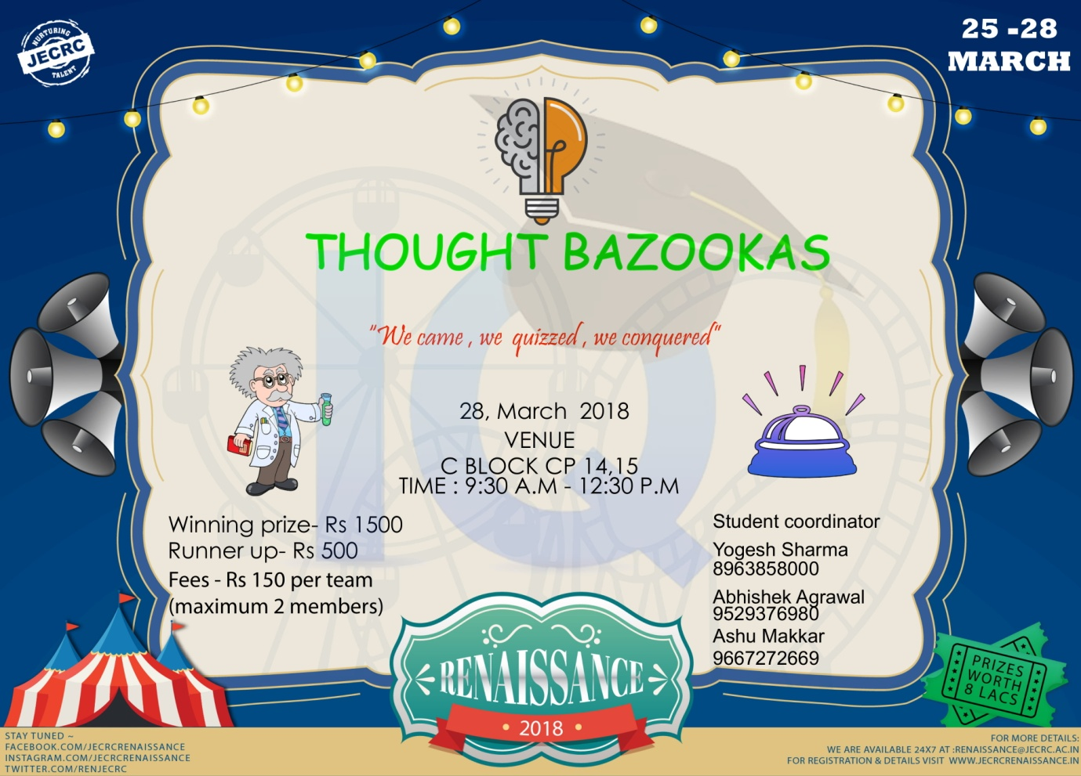

**Final List of events with Venue ,Date and Timimg**

|  |  |  |  |
| --- | --- | --- | --- |
| **S. No.** | **Event Name** | **Venue** | **Date&Timing** |
| 1 | TECHNOCRAZY | B-Block ,BLG-06 | 28/03/2018 ,12:30Pm-3:30Pm |
| 2 | TECHNO WORD CONTEST | B-Block ,BLG-19&BLG-8 | 25/03/2018 ,12:30Pm-3:30Pm |
| 3 | POSTER PRESENTATION | B-Block ,BLG-13 | 27/03/2018 ,9:30Am |
| 4 | ELECTRAZONE | B-Block ,BLG-13 | 26/03/2018 ,9:30Am-12:30Pm |
| 5 | TECHNICAL CROSS WORD | B-Block ,BLG-13 | 27/03/2018 ,1:00Pm-4:00Pm |
| 6 | ELECTRO QUIZZERS | **A-Block ,IBM lab** | 26/03/2018 ,12:30Pm-4:30Pm |
| 7 | TECH HUNT | B-Block ,BLG-19 ,b block fountain area | 27/03/2018 ,11:00Am-2:00Pm |
| 8 | EMBRIO | **A-Block Conference Hall** | 25/03/2018 ,11:00Am-4:00Pm |
| 9 | THOUGHT BAZOOKAS | **CP-14,15** | 28/03/2018 ,9:30Am-12:30Pm |

1. **TECHNOCRAZY**

**Faculty coordinators:**

Mrs.Sonali Chadha 8058600010

Mr.L.Senthil 8952934577

2. **TECHNO WORD CONTEST**

**Faculty coordinators:**

1) Mr.Atul Kulshrestha 9414573167

2) Mr. Manish Pal 9928481890

3) Mr.Sunil Kumar Sharma 7737509326

3**. POSTER PRESENTATION**

**Faculty Coordinators:**

1. Mr. Rahul Kumar Malee 9785845882

2. Mrs.Ravita Saraswat 9457488848

4. **ELECTRAZONE**

**Faculty Coordinators:**

1. Poonam Gupta 8058600010

2. Rahul Kumar Malee9785845882

5. **TECHNICAL CROSS WORD**

**Faculty Coordinators:**

1 Mr. Ashok Singh Chundawat 9887708601

2. Mrs. Yajusa Sharma 9982421234

3. Mr.Vishnu Datt Sharma 8107478865

4. Mr. Vishal Sharma 9829083223

6. **ELECTRO QUIZZERS**

**Faculty coordinator :**

1 Mr. Shailendra Shrivastava 9024699748

2 Mr.Manish pal 9928481890

7. **TECH HUNT**

**Faculty Coordinators:**

1.Geetika Mahur (9549318998)

2. Neha Agrawal (8058404226)

**8. EMBRIO(GIZMO)**

**Faculty Coordinator:**

**1** Neha Agrawal ,M-8058404226

2 Ram Singh , M-9887712330

3Gopal Tiwari ,M-8890750291

9. **THOUGHT BAZOOKAS**

**Faculty coordinator :**

1) Mr.Manish Pal 9928481890

2) Dr. Sandeep Vyas 9413965018